**CLOUD SECURITY AND MANAGEMENT LAB**

**LAB 4**

**Installation and configuration of virtualization using kvm (kernel based virtual machine)**

1. sudo apt update - downloads the package information from the Internet. It is useful to get info on an updated version of packages or their dependencies.

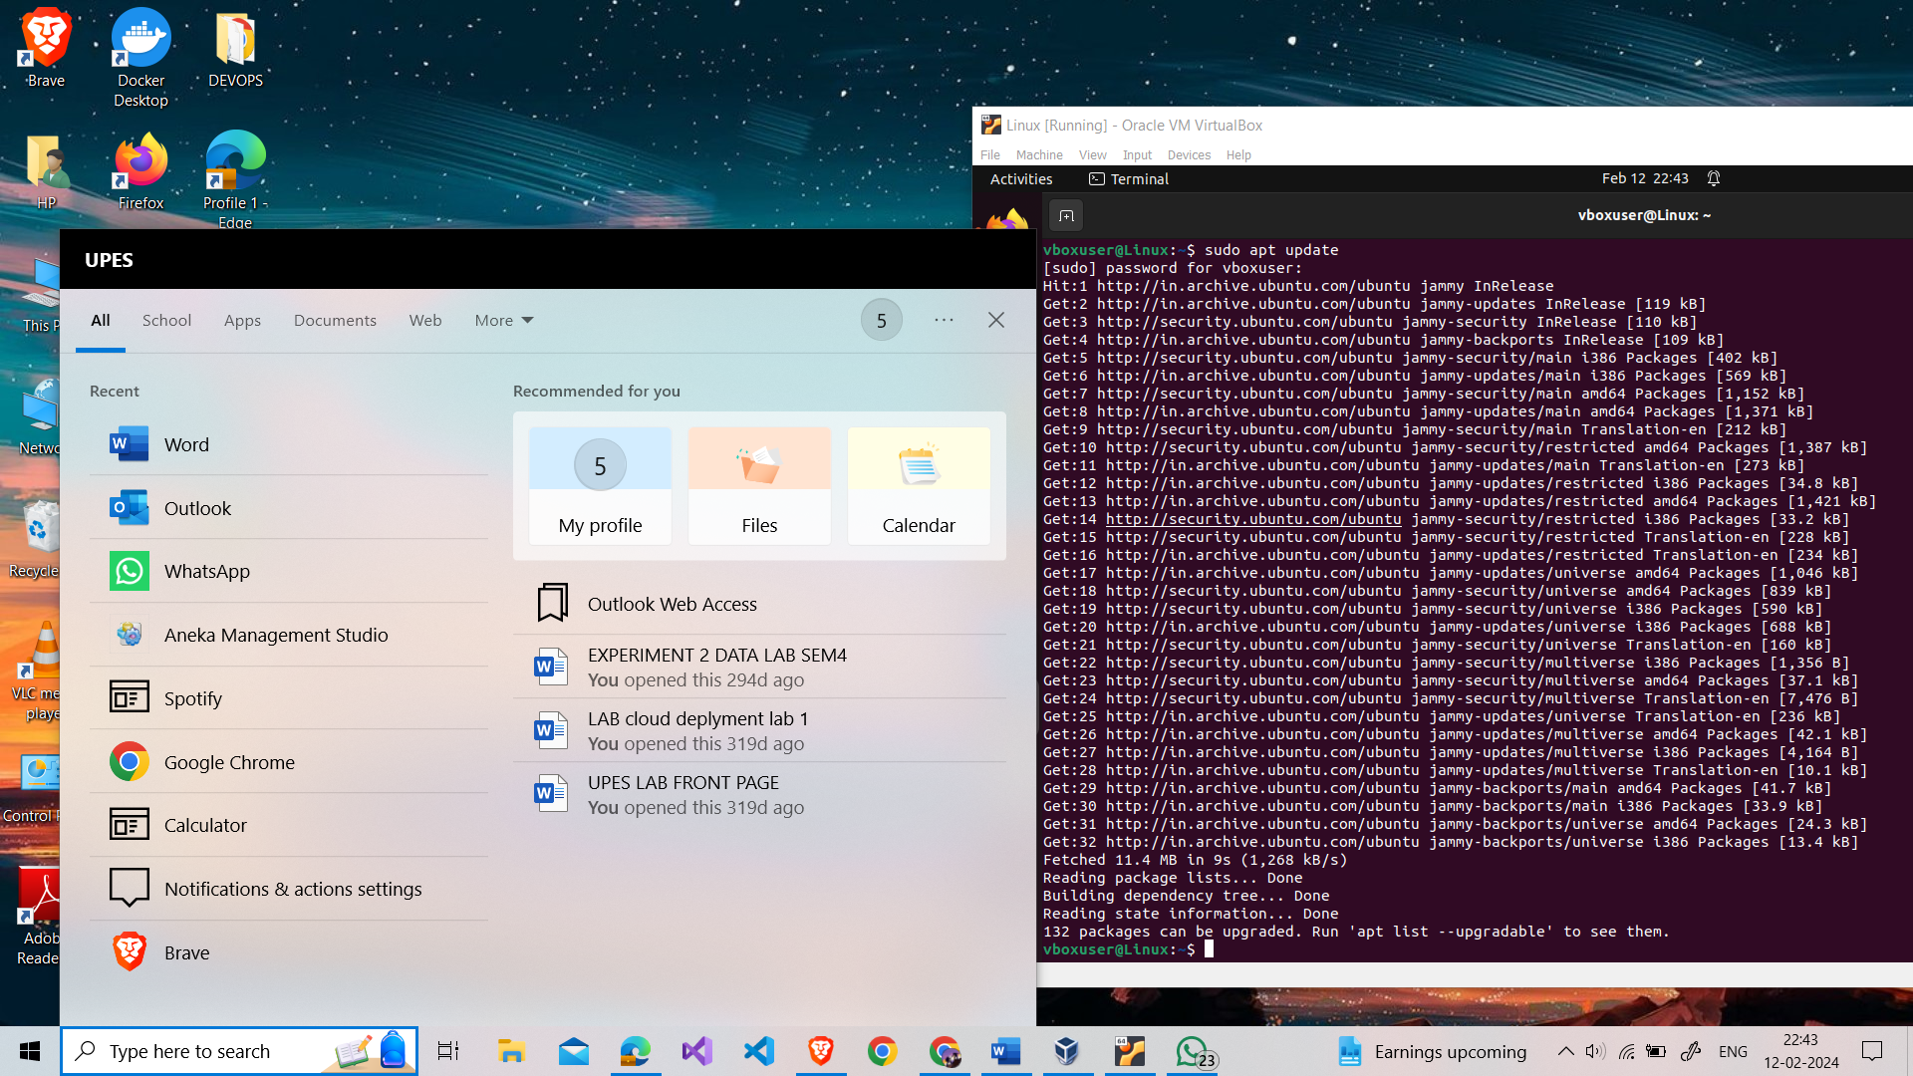

1. sudo apt install qemu-kvm libvirt-clients libvirt-daemon-system bridge-utils virtinst libvirt-daemon virt-manager - installs essential components for virtualization on Ubuntu or Debian-based Linux systems. It includes QEMU-KVM for hardware-assisted virtualization, libvirt and its clients for management via command-line interfaces, bridge-utils for configuring network bridges, virtinst for creating and managing virtual machines via command-line tools, libvirtd for managing virtualization platforms, and virt-manager for graphical virtual machine management. This comprehensive installation sets up both command-line and graphical interfaces for efficiently managing virtual machines and their associated infrastructure.

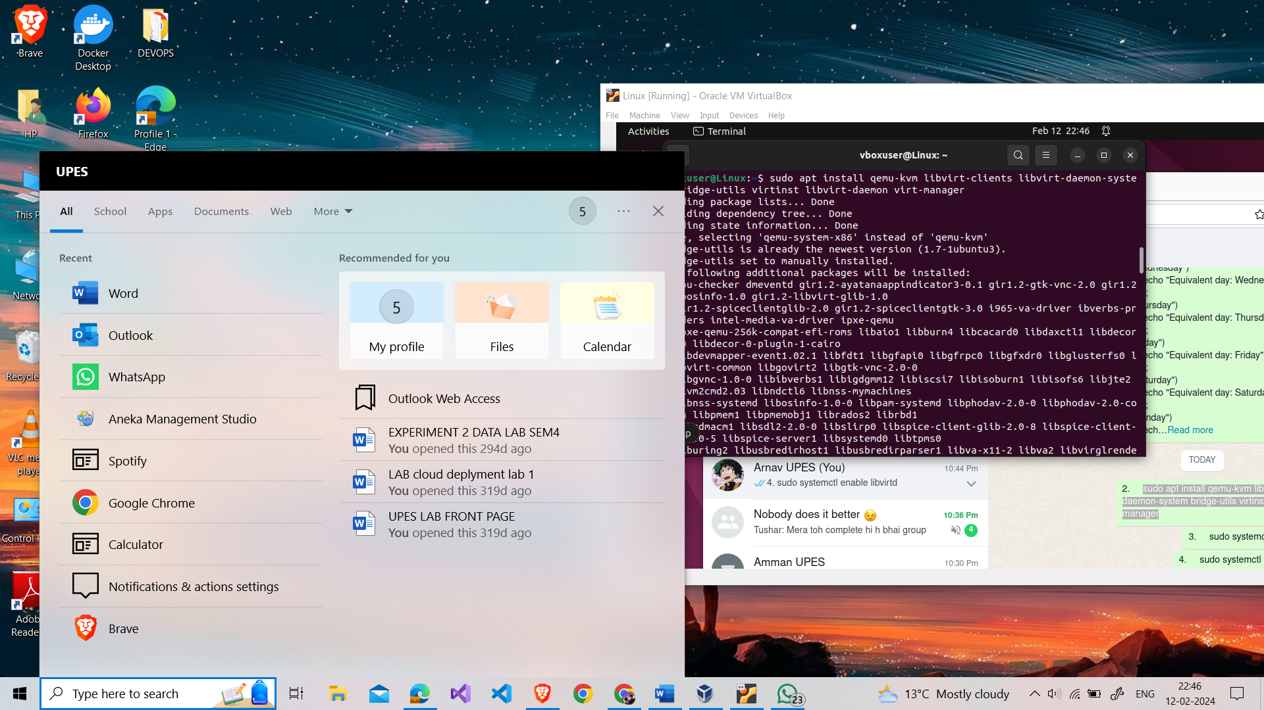

1. sudo systemctl start libvirtd - used to manually start the libvirtd service on Ubuntu or Debian-based Linux systems. This service is essential for managing virtualization platforms through the libvirt API.

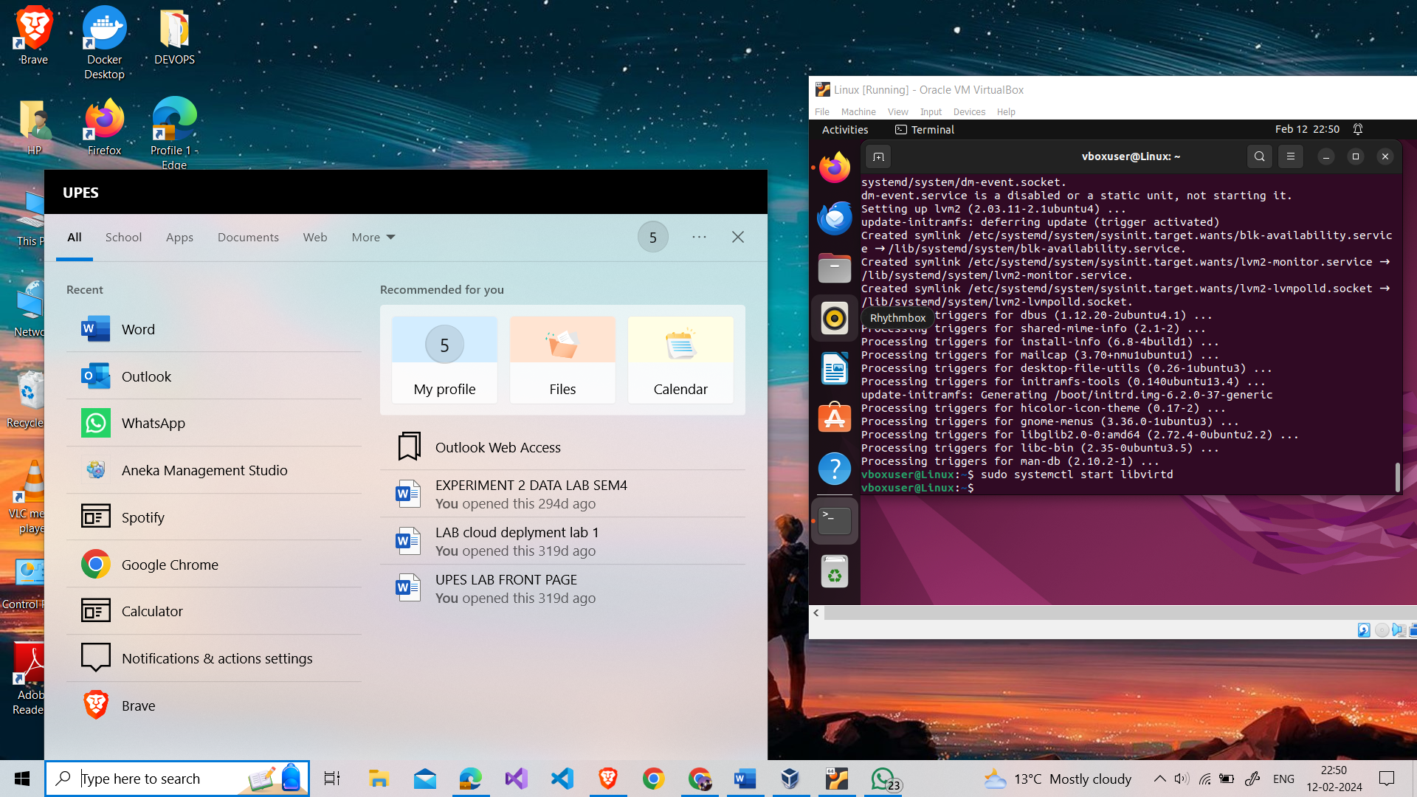

1. sudo systemctl enable libvirtd - enable the libvirtd service to start automatically at system boot, ensuring that virtualization resources are available consistently. 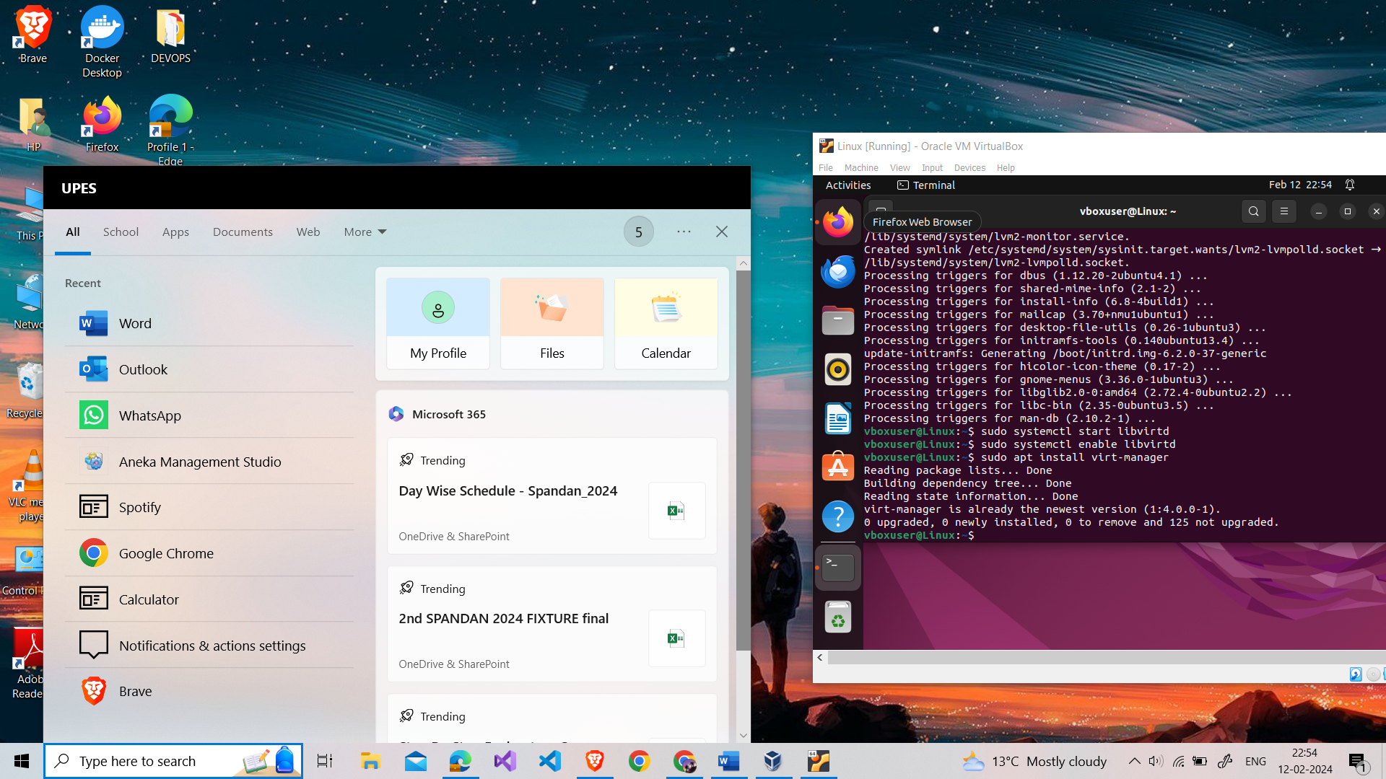
2. sudo apt install virt-manager - used to install the Virtual Machine Manager (virt-manager) on Ubuntu. By installing virt-manager, users gain access to a user-friendly environment for efficiently managing their virtualized infrastructure, improving productivity and simplifying virtual machine administration.



1. lsmod | grep kvm - used to check the status of the Kernel-based Virtual Machine (KVM) modules on a Linux system. It lists loaded kernel modules and filters the output to display only the lines containing "kvm".

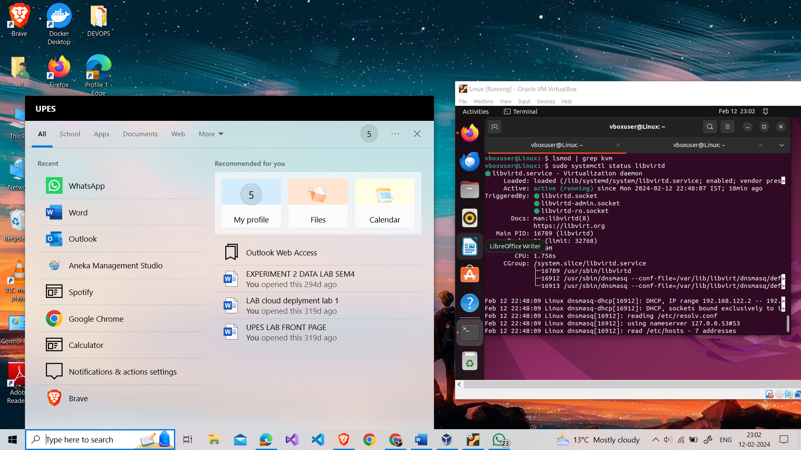

1. sudo systemctl status libvirtd - provides a concise status report of the libvirtd service on Ubuntu or Debian-based Linux systems. Running this command displays information such as the service's current state (active, inactive, or failed), its main process ID (PID), resource usage metrics, and any recent log entries



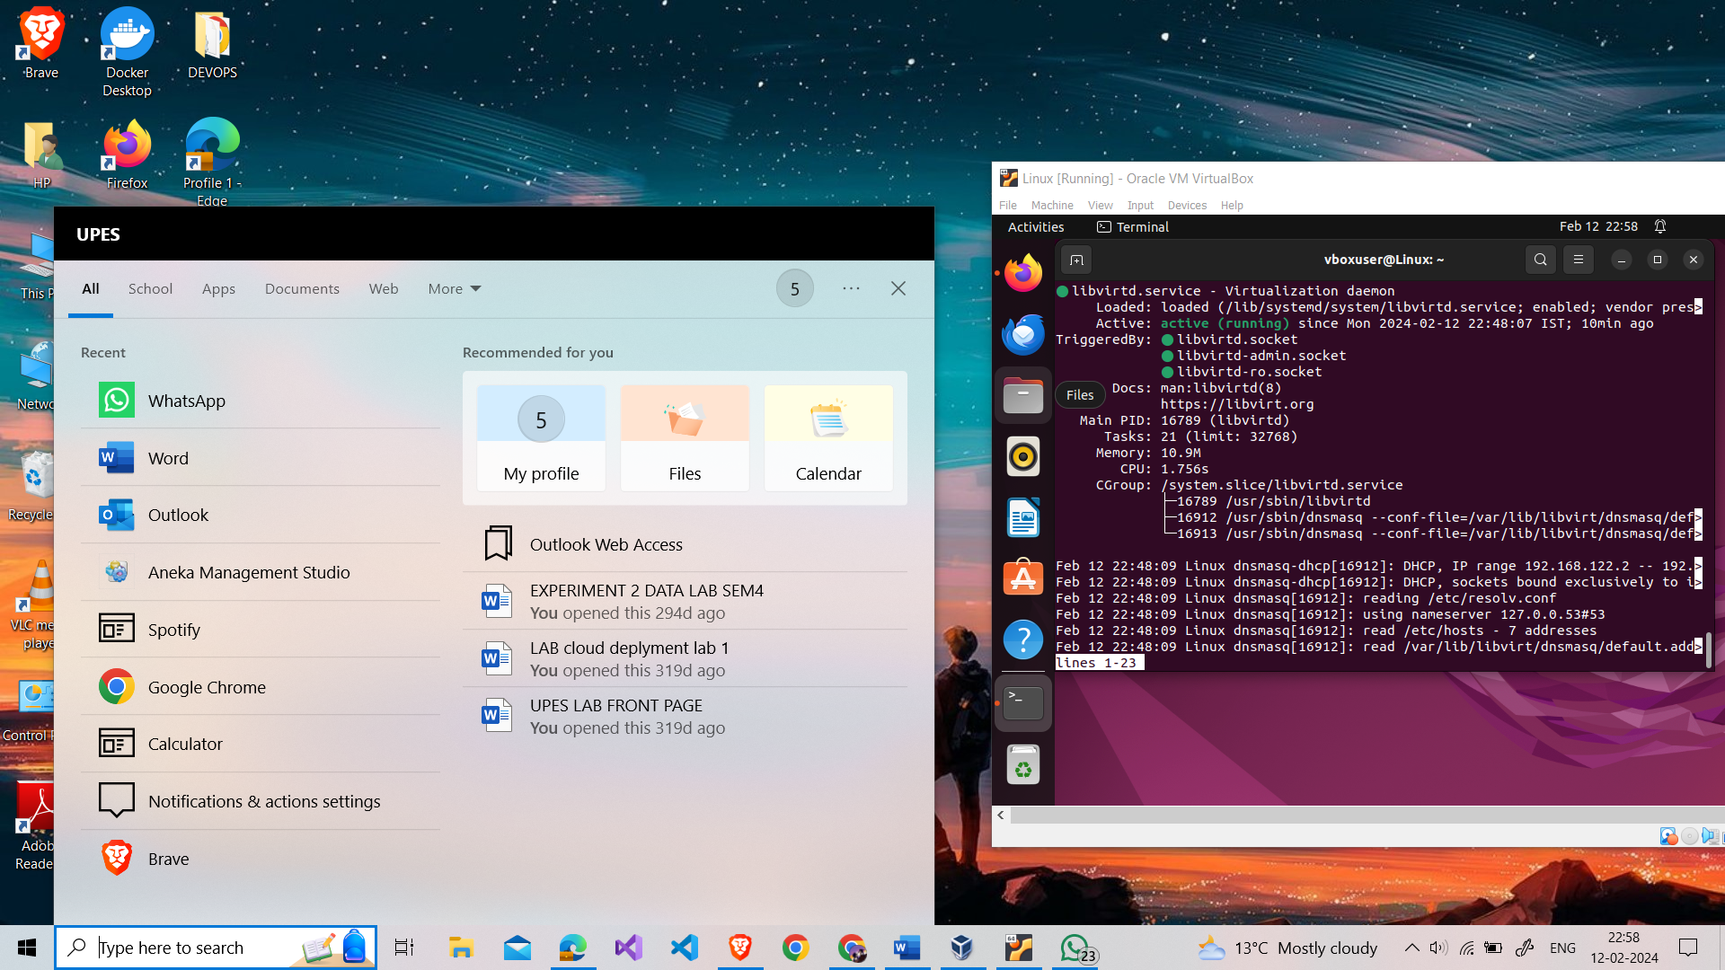

1. **What is kernel in operating system?**

The kernel is the core of an operating system (OS). It acts as a bridge between software and hardware, handling tasks such as process management, memory management, device management, and input/output operations. It is responsible for:

* Managing hardware resources (CPU, memory, storage, devices)
* Providing core services like memory management, process scheduling, I/O handling, and communication
* Interacting with hardware through device drivers
* Providing an interface for user applications and programs

Think of it as the conductor of an orchestra, coordinating all the instruments (hardware) to produce a harmonious performance (computing tasks).

1. **Define KVM and explain how it differs from other types of hypervisor.**

* KVM is an open-source virtualization technology built into the Linux kernel.
* It allows the Linux kernel to act as a type 1 hypervisor, directly controlling the hardware and enabling the creation and management of isolated virtual machines (VMs).
* VMs run guest operating systems independently within the host OS.

Differences from other Hypervisor Types:

* Type 1 (Bare-metal): KVM falls into this category, running directly on the hardware like VMware ESXi or Microsoft Hyper-V.
* Type 2 (Hosted): These run on top of an existing OS like VirtualBox, requiring fewer resources but offering lower performance.

1. **Is it possible for the Windows kernel to function as a type 1 hypervisor? explain with example.**

* No, the Windows kernel is not designed for or officially supported as a type 1 hypervisor.
* However, some community projects like Hyper-V Lite and WHPX use modified Windows kernels for limited hypervisor functionality, but these are not mainstream solutions.
* Hyper-V is a Type 1 hypervisor that runs directly on the hardware and provides virtualization capabilities. By using Hyper-V, the Windows kernel can function as a hypervisor, allowing users to create and manage virtual machines on Windows-based systems.

1. **What are hardware virtualization extensions and how do they enhance virtualization performance in KVM?**

* These are hardware features (Intel VT-x, AMD AMD-V) that assist hypervisors in managing resources and improving performance.
* KVM leverages these extensions for:
* Direct assignment of hardware resources to VMs, increasing efficiency.
* Faster VM creation and startup by offloading tasks to hardware.
* Enhanced security through hardware-based isolation.

1. **Describe the role of ‘Qemu’ in junction with KVM and how they work together.**

* Qemu is a standalone user-space emulator/virtualizer for various architectures.
* KVM provides hardware acceleration for qemu, significantly improving performance.

They work together:

* Qemu emulates virtual hardware devices.
* KVM leverages hardware extensions for efficient execution.

QEMU (Quick Emulator) is an open-source emulator that provides hardware emulation and virtualization capabilities. When used in conjunction with KVM, QEMU acts as the userspace component of the virtualization stack, providing device emulation and management functionalities. QEMU translates guest instructions to host instructions and handles I/O operations, while KVM leverages hardware virtualization extensions to accelerate CPU virtualization. Together, QEMU and KVM enable efficient virtualization on Linux systems, allowing users to run multiple virtual machines with near-native performance.

1. **Explain the significance of KVM being integrated into the Linux kernel.**

The integration of KVM into the Linux kernel is significant as it enables the Linux kernel to function as a hypervisor, providing native virtualization capabilities without the need for additional software layers. By incorporating KVM directly into the kernel, Linux distributions can offer a robust and efficient virtualization platform that leverages the kernel's stability, security, and performance optimizations. This integration simplifies virtualization deployment and management, enhances system reliability, and improves overall virtualization performance.

1. **What is ‘Lib virt’ and how does it contribute to the management of KVM based virtual machines?**

Libvirt is an open-source API and management tool that provides a unified interface for managing various virtualization technologies, including KVM-based virtual machines. Libvirt abstracts the underlying virtualization platforms and provides a common set of APIs and management tools for interacting with virtualized resources. It simplifies the management of virtual machines by offering features such as VM lifecycle management, resource allocation, and configuration management. Libvirt integrates seamlessly with KVM, allowing users to manage KVM-based virtual machines efficiently and effectively.

* Libvirt is an open-source API for managing virtual machines on various hypervisors (KVM, Xen, etc.).
* It provides a common interface for:
* Creating, starting, stopping, and migrating VMs.
* Managing VM resources (CPU, memory, storage).
* Defining VM configurations.
* Simplifies and standardizes KVM management for administrators.

1. **Discuss the performance benefits of using KVM for virtualization.**

* Low overhead: Tight integration with Linux kernel results in efficient resource utilization.
* Hardware acceleration: Leverages hardware extensions for direct resource access and faster execution.
* Minimal resource consumption: Runs efficiently on older hardware due to low footprint.
* Wide range of supported guests: Can run various OSes (Linux, Windows, etc.) due to qemu emulation.

In conclusion, KVM offers a powerful and versatile virtualization solution for Linux environments, combining open-source flexibility, deep integration, and strong performance.